**Noam Chomsky Classification**

According to Noam Chomosky, there are four types of grammars − Type 0, Type 1, Type 2, and Type 3. The following table shows how they differ from each other −

|  |  |  |  |
| --- | --- | --- | --- |
| **Grammar Type** | **Grammar Accepted** | **Language Accepted** | **Automaton** |
| Type 0 | Unrestricted grammar | Recursively enumerable language | Turing Machine |
| Type 1 | Context-sensitive grammar | Context-sensitive language | Linear-bounded automaton |
| Type 2 | Context-free grammar | Context-free language | Pushdown automaton |
| Type 3 | Regular grammar | Regular language | Finite state automaton |

Take a look at the following illustration. It shows the scope of each type of grammar −

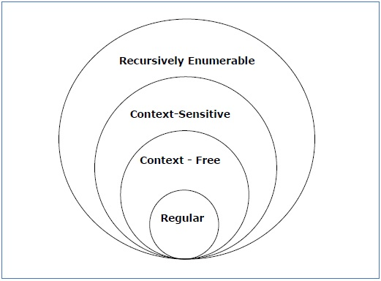

Type - 3 Grammar

**Type-3 grammars** generate regular languages. Type-3 grammars must have a single non-terminal on the left-hand side and a right-hand side consisting of a single terminal or single terminal followed by a single non-terminal.

The productions must be in the form **X → a or X → aY**

where **X, Y ∈ N** (Non terminal)

and **a ∈ T** (Terminal)

The rule **S → ε** is allowed if **S** does not appear on the right side of any rule.

Example

X → ε

X → a | aY

Y → b

Type - 2 Grammar

**Type-2 grammars** generate context-free languages.

The productions must be in the form **A → γ**

where **A ∈ N** (Non terminal)

and **γ ∈ (T ∪ N)\*** (String of terminals and non-terminals).

These languages generated by these grammars are be recognized by a non-deterministic pushdown automaton.

Example

S → X a

X → a

X → aX

X → abc

X → ε

Type - 1 Grammar

**Type-1 grammars** generate context-sensitive languages. The productions must be in the form

**α A β → α γ β**

where **A ∈ N** (Non-terminal)

and **α, β, γ ∈ (T ∪ N)\*** (Strings of terminals and non-terminals)

The strings **α** and **β** may be empty, but **γ** must be non-empty.

The rule **S → ε** is allowed if S does not appear on the right side of any rule. The languages generated by these grammars are recognized by a linear bounded automaton.

Example

AB → AbBc

A → bcA

B → b

Type - 0 Grammar

**Type-0 grammars** generate recursively enumerable languages. The productions have no restrictions. They are any phase structure grammar including all formal grammars.

They generate the languages that are recognized by a Turing machine.

The productions can be in the form of **α → β** where **α** is a string of terminals and nonterminals with at least one non-terminal and **α** cannot be null. **β** is a string of terminals and non-terminals.

Example

S → ACaB

Bc → acB

CB → DB

aD → Db